Software Requirements Specification
for
Blood Bank Management System
THE PROJECT IS DEVELOPED & PRESENTED BY:

- FAWAD AHMED BAIG (COSC221101049)
- SHAHBAZ AHMAD MAZARI (COSC221101037)
- ARIF ISMAIL (COSC221101036)

Introduction

Purpose
The purpose of this document is to provide a detailed description of the requirements for developing a Blood Bank Management System. This system will efficiently manage various aspects related to blood banks, including inventory, donors, recipients, and other related operations.

Intended Audience and Reading Suggestions
The intended audience for this document includes the following stakeholders:

- Development Team:

- Project Managers and Stakeholders:

- Blood Bank Staff and Administrators:

- Quality Assurance (QA) Team:

- Technical Writers and Documentation Team:

- Other Relevant Parties:

Any other individuals or groups involved in the project (e.g., external consultants, auditors).
They should read relevant sections based on their roles and responsibilities.

Reading Suggestions:

- Start by reading the Purpose section (1.1) to understand the document’s context.
- Review the Scope (2.2) to grasp the system’s boundaries and functionalities.
- Pay attention to the Key Features and Requirements (Section 5) for detailed information on system features.
- Explore the Non-Functional Requirements (Section 8) to understand aspects like security, performance, and reliability.

Project Scope
The Blood Bank Management System will be a comprehensive software solution that enables effective management of the following activities:
- Inventory Management: Tracking blood stock levels, expiration dates, and types.
- Donor and Recipient Information: Recording donor details, recipient requests, and blood transfusion history.
- Blood Donation Drives: Managing blood donation events and campaigns.

References
- Management of Blood Donation System: Literature Review and Research Perspectives
- Data Warehouse Based Analysis with Integrated Blood Donation Management System
- Blood Bank Management System

Overall Description

Product Perspective
The Blood Bank Management System (BBMS) is designed to operate within a specific context and interact with various components. Here are the key aspects of its product perspective:

- System Context:

- The BBMS is part of a larger healthcare ecosystem, including hospitals, clinics, and blood banks.
- It interacts with users (donors, recipients, administrators) and other systems (inventory management, hospital databases).

- Integration Points:

- The BBMS integrates with existing hospital information systems to exchange data related to blood donations, inventory, and transfusions.
- It communicates with external blood banks to request or provide blood units.

- Data Flow:

- Data flows into the BBMS from donors during blood donation events.
- It flows out to recipients when blood units are allocated for transfusion.
- Inventory updates occur based on donations and usage.

- User Roles:

- Donors: Interact with the system during blood donation drives.
- Recipients: Request blood units for transfusion.
- Administrators: Manage inventory, donor records, and requests.

- Dependencies:

- The BBMS relies on accurate donor information, blood type compatibility, and proper storage conditions.
- It depends on timely communication with external blood banks.

- Constraints:

- Compliance with healthcare regulations and safety standards.
- Integration with existing hospital workflows.

Product Features
Managing and monitoring the blood transfer from donor to patient including saving data of the donors and patients and updating and deleting the data using database and SQL. Separate login profiles for users and admin.

User Classes and Characteristics

- System Owner:

- The organization or entity responsible for managing and maintaining the BBMS.
- They oversee system operations, upgrades, and compliance.

- Administrators:

Characteristics:
- Authorized personnel within the blood bank.
- Familiar with blood bank operations and protocols.
- Responsible for system administration, user management, and data entry.

Roles:
- Manage donor and recipient records.
- Monitor blood stock levels.
- Allocate blood units for transfusion.
- Generate reports.

- Donors:

Characteristics:

- Individuals who voluntarily donate blood.
- May have varying levels of computer literacy.
- May be regular or occasional donors.

Roles:

- Register in the system.
- View their donation history.
- Receive alerts for donation drives.

- Recipients:

Characteristics:

- Patients in need of blood transfusions.
- May be in critical conditions.
- May not directly interact with the system.

Roles:

- Request specific blood types.
- Receive blood units based on medical requirements.

- Public Users:

Characteristics:
- General public interested in blood donation.
- May visit the blood bank website.
- May participate in blood donation events.

Roles:
- View upcoming donation drives.
- Register as potential donors.

Operating Environment
- The BBMS can be deployed in a hospital or blood bank setting.
- It runs on servers or cloud infrastructure.

User Documentation

- Introduction:

- Provide an overview of the BBMS and its purpose.
- Explain why the system is essential for blood bank operations.

- Getting Started:

- Instructions for accessing the BBMS (e.g., web URL, login credentials).
- System requirements (supported browsers, internet connection).

- User Roles and Permissions:

- Describe the different user roles (administrators, donors, recipients).
- Explain what each role can do within the system.

- User Interface Guide:

- Walkthrough of the BBMS interface:
- How to log in.
- Navigation within the system.
- Accessing different modules (donor management, inventory, requests).

- Donor Registration:

- Step-by-step guide for donors to register in the system.
- How to update personal information.

- Recipient Requests:

- Instructions for recipients to request blood units.
- How to check blood availability.

- Inventory Management:

- How to view blood stock levels.
- Updating inventory records.

- Security and Privacy:

- Remind users to keep login credentials confidential.
- Explain data privacy measures.

- Troubleshooting and FAQs:

- Common issues and their solutions.
- Frequently asked questions.

- Contact Information:

- Provide support contact details (email, phone) for assistance.

Assumptions and Dependencies

- Availability of Third-Party Components:

- The system assumes the availability and compatibility of third-party components such as database management systems (DBMS) and web servers.
- These components are essential for the functioning of the BBMS.

- External Interfaces:

- Dependencies exist on external systems for data exchange and integration:
- Healthcare Facility Management Systems: Integration with existing hospital information systems (HIS) or laboratory management systems.
- Regulatory Databases: Compliance with regulatory requirements related to blood bank operations.

System Features

System Feature 1: Donor Registration and Management
Description:

- Allows donors to register in the system.
- Manages donor information, including personal details, blood type, and donation history.
- Provides an interface for donors to update their information.

Functionality:

- Donor registration form with fields for personal details (name, contact information, age, etc.).
- Blood type selection (A, B, AB, O, Rh+/-).
- Recording of donation dates, quantities, and results (e.g., successful donation, deferral).
- Alerts for eligible donors when it’s time for their next donation.

Benefits:

- Efficient management of donor records.
- Improved communication with donors.
- Ensures accurate blood type information for transfusion compatibility.

System Feature 2 : Blood Inventory Management
Description:
- Efficiently manages blood inventory within the blood bank.
- Tracks blood stock levels, expiration dates, and types (e.g., A+, B-, O+).
- Provides real-time availability information.

Functionality:

Inventory Dashboard:

- Displays current stock levels for each blood type.
- Alerts when stock falls below a predefined threshold.

Expiration Tracking:

- Notifies staff about blood units approaching expiration.
- Facilitates proper rotation (first in, first out).

Blood Type Matching:

- Ensures compatibility between donor blood types and recipient needs.
- Alerts when specific blood types are critically low.

Benefits:

- Prevents shortages or excesses of specific blood types.
- Reduces wastage due to expired blood units.
- Enables efficient allocation during emergencies.

System Feature 3: Emergency Blood Requests and Availability:

- When a blood emergency arises, the system should quickly identify available blood units based on the required blood group.
- It can broadcast messages to donors with matching blood types, notifying them of the urgent need.
- Features include real-time availability checks, patient details, and seamless communication with donors.

External Interface Requirements

User Interfaces

- Donor Registration Interface:

- This interface allows blood donors to register by providing their personal and medical information.
Key features:
- Form-based registration: Donors fill out a form with details such as name, contact information, blood type, and medical history.
- Update functionality: Registered donors can update their information as needed.
- View donation history: Donors can access their donation history.
- Notifications: Donors receive notifications about upcoming blood drives or shortages.

- Patient Registration Interface:

Similar to donor registration, this interface collects patient information.
Features:
- Data entry: Staff members can efficiently collect patient details.
- Search filters: Robust search filters allow quick retrieval of patient information based on various criteria.
- Instant search: Enables immediate access to required blood groups for patient needs.

- Blood Stock Management Interface:

This interface focuses on managing blood inventory.
Features:
- Inventory tracking: Staff can monitor blood quantities, expiration dates, and donor information.
- Dynamic data visualization: Real-time dashboards provide insights into inventory levels.
- Efficient interaction: Intuitive tools facilitate data entry, search, and visualization.

- Blood Transfer Interface:

Used for transferring blood between different locations (e.g., hospitals, blood banks).
Features:
- Request and approval process: Enables seamless transfer requests and approvals.
- Inventory updates: Tracks blood movement accurately.

- Dashboard Interface:

Provides an overview of critical information.
Features:
- Donor details: Contact information, blood type, last donation details, etc.
- Emergency donor reach: Facilitates quick communication with donors during emergencies.

- Login Page Interface:

The entry point for authorized users.
Features:
- User authentication: Ensures secure access.
- Role-based permissions: Controls user actions based on roles (e.g., admin, staff).

Hardware Interfaces
- Server: A dedicated server to host the BBMS.
- Storage: Sufficient storage for donor records, blood inventory, and transaction logs.
- Network Infrastructure: Reliable network connectivity for data exchange.

Software Interfaces
- Operating System: Compatible with Windows
- Database Management System

Other Nonfunctional Requirements

Performance Requirements:
- Response Time: The system should provide timely responses to user requests. For instance, when checking patient information, acknowledgment should occur within one second.
- Capacity: The BBMS must support at least 1000 concurrent users efficiently.
- Scalability: The system should handle increasing loads without significant performance degradation.

Safety Requirements:
- Blood Safety: The BBMS must ensure the safety of blood units. This includes proper handling, storage, and tracking to prevent contamination or spoilage.
- Emergency Issue Handling: In emergency situations, the system should swiftly facilitate blood transfusion requests.
- Donor Safety: The system should maintain accurate donor records, ensuring safe donation practices.

Security Requirements
- Access Control: Role-based access control (e.g., admin, staff, donor) to prevent unauthorized access.
- Data Encryption: Sensitive data (e.g., donor medical history, patient details) should be encrypted during transmission and storage.
- Audit Trails: Log and monitor user activities for accountability.
Authentication and Authorization: Secure login mechanisms to verify user identities and grant appropriate permissions.

Software Quality Attributes:
- Reliability: The BBMS should be dependable, minimizing downtime or errors.
- Maintainability: Code should be well-organized, documented, and easy to maintain.
- Usability: Intuitive user interfaces for efficient interaction.
- Availability: The system should be accessible when needed.
- Performance Efficiency: Optimize resource usage (CPU, memory, network) to enhance responsiveness.
- Portability: Consider compatibility with different platforms (e.g., web, mobile).

Analysis Model:

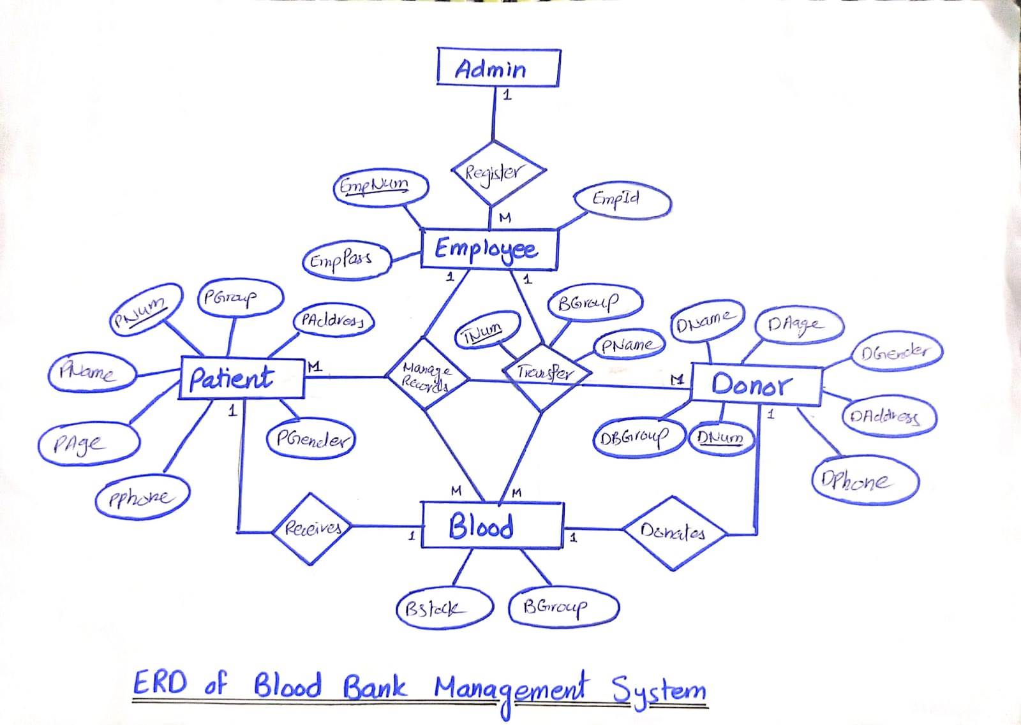

Existing System Analysis:
- System Analysis of Blood Bank Management System of Hamza Lab

